- SIGNAL GENERATION AND BASIC SIGNAL OPERATIONS

Experiment 1.4
Step and Ramp Functions (Continuous & Discrete)
Aim
Generate and plot unit impulse, unit step, and ramp functions.
Apparatus Required
PC with MATLAB.
Program (MATLAB)
% Step and Ramp Functions (Continuous & Discrete)
clc;
clear;
close all;
%% Continuous-Time Signals
t = -5:0.01:5;
% Continuous Unit Step Function
u = double(t >= 0);
% Continuous Ramp Function
r = t .* (t >= 0);
%% Discrete-Time Signals
n = -5:5;
% Discrete Unit Step Function
ud = double(n >= 0);
% Discrete Ramp Function
rd = n .* (n >= 0);
%% Plotting
figure;
subplot(2,2,1);
plot(t,u,'LineWidth',2);
grid on;
title('Continuous Unit Step Function');
xlabel('Time (t)');
ylabel('Amplitude');
subplot(2,2,2);
plot(t,r,'LineWidth',2);
grid on;
title('Continuous Ramp Function');
xlabel('Time (t)');
ylabel('Amplitude');
subplot(2,2,3);
stem(n,ud,'filled');
grid on;
title('Discrete Unit Step Function');
xlabel('Sample Index (n)');
ylabel('Amplitude');
subplot(2,2,4);
stem(n,rd,'filled');
grid on;
title('Discrete Ramp Function');
xlabel('Sample Index (n)');
ylabel('Amplitude');
Output Generated Graph
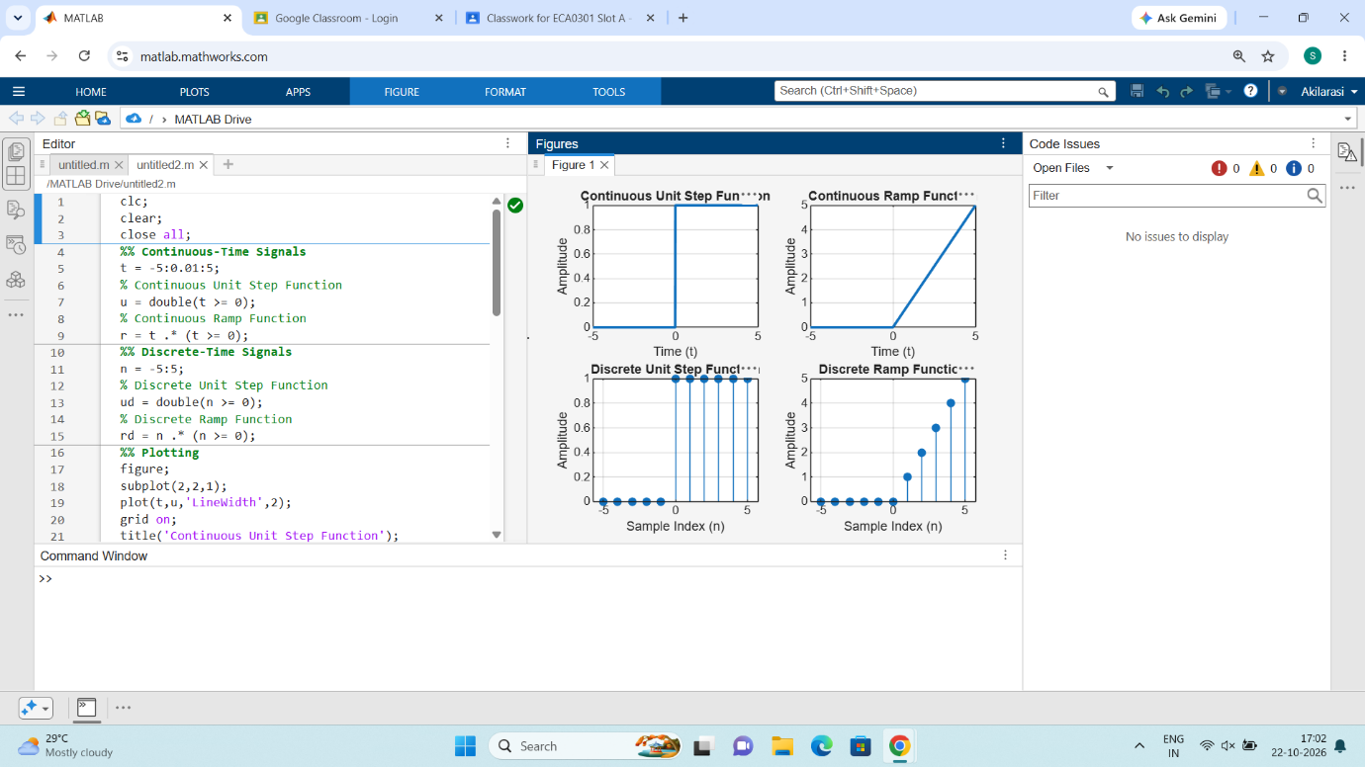
Result
Step and Ramp Functions (Continuous & Discrete)

